Joint seminar by Free University of Berlin, Nagasaki University and Meijo University

This seminar aims to exchange research ideas between three Universities (Faculty of Economics, Meijo University, Graduate School of Fisheries and Environmental Sciences, Nagasaki University and department of history and cultural studies of University of Berlin) and to broaden and deepen understanding of the subjects regarding economic development and sustainable development in East Asia.
- Title: Sustainable Development in North East Asia: Energy transition and Economic Effects
- Event details
Date: Monday, 10th September, 2019 (tentative)
Time: 13:00-19:00
Venue: Free University of Berlin
Language: Korean and English
- Programme outline
13:00 Opening and introduction
13:10-14:00 Presentation by Prof. Soocheol Lee, Meijo University, Japan
Title: Policy for energy transition in Japan and Korea (tentative)
14:00-14:50 Presentation by assoc. Prof. Sunhee Suk, Nagasaki University, Japan
Title: Locally-led renewable energy implementation in South Korea
14:50-15:10 Coffee time
15:10-16:00 Presentation by Dr. Jiyeon Park, Free University of Berlin, Germany
Title: Urban planning in North Korea (tentative)
16:00-16:50 Presentation by Dr. Sangkook Kim, Free University of Berlin, Germany
Title: Reclamation project and sustainable development in North Korea (tentative)
16:50-17:00 Closing
17:00-19:00 Networking lunch
- About the Universities
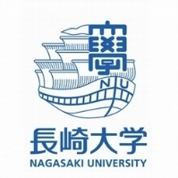 | Nagasaki University, a national university of Japan, was established in 1949 by incorporating several national institutions, namely, Nagasaki Medical College (founded in November 1857), Nagasaki College of Economics (founded in March 1905), Nagasaki Normal School and etc. As being located in a region that geographically faces the Asian Continent across the East China Sea, it possesses the history and memory of Dejima and is invested with a unique mission by the atomic bombing.
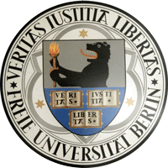 | Freie Universität is one of the eleven universities to have been successful in all three lines of funding in the German government's Excellence Initiative in 2012. The main features of Freie Universität’s research activities include the broad variety of global academic and scientific cooperation arrangements in place as part of alliance projects and networks with other entities active in research, alongside the university’s innovative support concepts for junior scholars and scientists and the scope of the external funding the university raises.
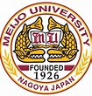 | Meijo University is a private university located in Nagoya, Aichi Prefecture, Japan. It has over 90 years of history that can be traced back to the establishment of the Nagoya Science and Technology Course in 1926. As one of the largest universities in the Chubu region, Meijo University is a comprehensive learning institution that supports a wide range of academic fields from the humanities to physical sciences. To foster the human resources of the next generation, the university continues to tackle ongoing challenges by further enhancing its campus and creating new faculties.

